**Exercise**

Make the following parts: 1xa, 1xb, 4xc, and 1xd according to the provided dimensions. Then assemble the parts (*For the sake of clarity, a different color has been used for the various components )*

***Final Assembly***

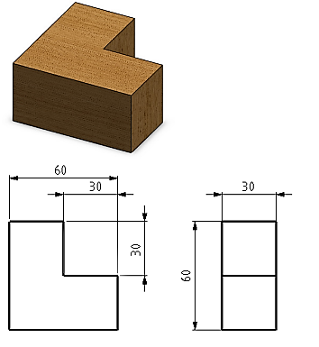

***Part a Part b***

***Part c***

***Part d***